AUTOMATED EMAIL SUMMIT TICKET “SPONSORED PRICE”

Dear friend,
Warm greetings from the Organizing Team of the Global Conscious Food Systems Summit.
We are delighted to inform you that your application has been successfully approved to join the Global Conscious Food Systems Summit, to be held from 31 August to 4 September in Paro, Bhutan.
This message outlines the steps required to onboard you to the Summit. Please review carefully and take the necessary actions.
- Please immediately send to us a scanned copy of your valid passport in reply to this message, copying Neema Tamang <neema.tamang@bhutanmindfulness.com> and pema.tshogyal@bhutanmindfulness.com
- Visa application: you are invited to proceed with your visa application. Kindly ensure you have a valid email address for correspondence and prepare the following required documents:
- Completed and signed Form VISA2025
- Copy of your passport
- Digital passport-sized photograph
- Fill up Applicant Visa Details Submission form and upload the above documents in the form.
Please note that the Sustainable Development Fee (SDF) waiver for this Summit is valid for 10 days starting from 28th August. Therefore, Summit visa dates should fall within the period of 28th August to 6th September. Participants who wish to extend their stay beyond this period will be required to convert their visa from a Non-Tourist Visa to a Tourist Visa after their arrival in Bhutan, subject to applicable visa fees and daily SDF charges. Please refer to Section 16: Extending Your Stay in Bhutan in the attached Information Note for further details.
General Conditions for Entry into Bhutan:
- The passport must be valid for six months from the intended date of departure from Bhutan
- Passport copy should be in JPEG or PNG format.
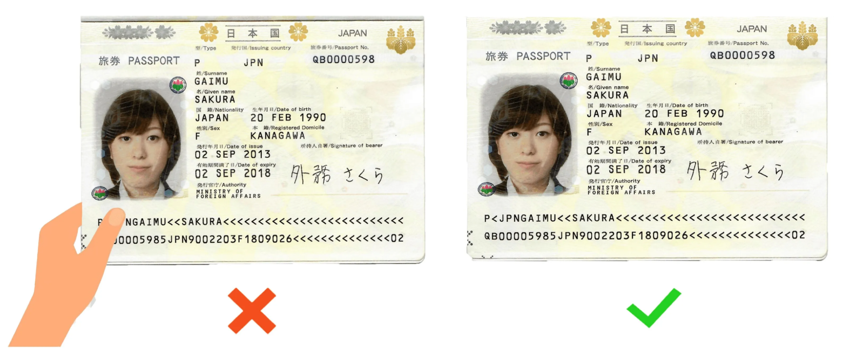

- Requirement for Passport-sized photograph
  - Should not be older than six months
  - Have a white background (without border)
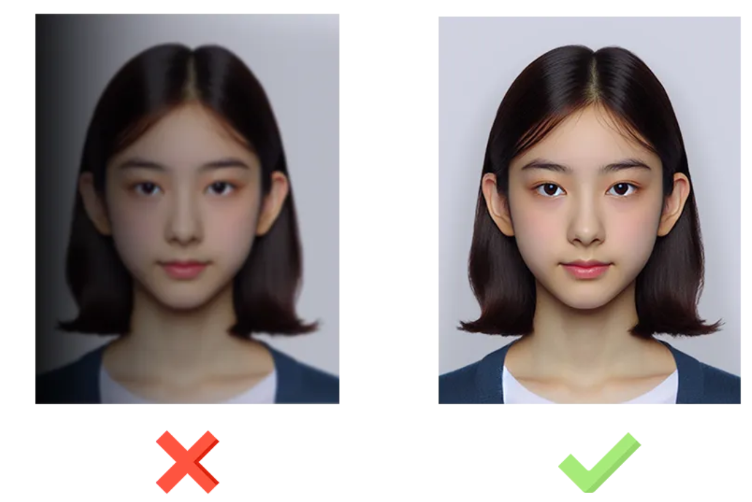
  - Should be color copy, portrait style with eyes open and forehead & ears clearly visible.

- The visa application fee (already included in your ticket price along with the application assistance fee) is non-refundable and non-transferable.
- The passport used for your e-visa application must be presented at the Port of Entry.
- The issuance of an e-visa does not guarantee entry or stay in the Kingdom. Admission is subject to approval by immigration authorities in accordance with national regulations.
- Visitors entering as non-immigrants are not eligible to apply for immigrant status or citizenship.
Should you require any assistance during the visa form fillup or if you have any other queries, please do not hesitate to reach out. We are happy to support you.
We look forward to welcoming you to Bhutan for an inspiring and meaningful Summit experience.
Warm regards,
The Organizing Team of the Global Conscious Food Systems Summit

